**Conversify**

**Ditch the jargon, speak from the heart:**

**Imagine a space where conversations go beyond likes and emojis. Dive into deep, meaningful threads with friends, spark debates that branch out in exciting ways, and connect with like-minded folks on multiple levels. Our platform is more than just a digital space, it's a welcoming, inclusive community where every voice and opinion matters.**

**DESIGN DOCUMENT**

**Technology Stack**

**Frontend**

* **Nextjs**:Next.js is a React framework that simplifies server-side rendering, static site generation, and client-side routing, offering a fast and SEO-friendly foundation for web applications.
* **TypeScript**: We use TypeScript to add static typing to JavaScript, enhancing code reliability and enabling better tooling support, leading to more scalable and maintainable applications.
* **Shadcn/UI**: We will use Shadcn to create customizable components for streamlined app development. Open-source design, enhancing user experience with ease of integration
* **Tailwind CSS**: A utility-first framework that simplifies development with pre-designed classes for rapid prototyping and easy style maintenance.
* **Uploading**: We will use uploadthing for file uploading and sharing with streamlined features for secure uploads and customizable sharing settings, enhancing collaboration for individuals and teams.

**Backend**

* **Nodejs**: We will use Nodejs for the backend developer with Nextjs for the server-side rendering. It's lightweight, efficient, and event-driven, making it perfect for building scalable network applications.
* **Express.js**: Manages routing, middleware, and HTTP requests on the server side, providing a robust foundation for RESTful APIs.

* **MongoDB**: Selected for its flexibility and scalability, storing various data types such as user profiles and property listings for the real estate website.
* **Mongoose**: Simplifies interactions with MongoDB by offering schema validation and modeling capabilities, optimizing database operations.

**Authentication**

* **Clerk:** Clerk manages the full session lifecycle, including critical security functionality like active device monitoring and session revocation.

Offers multiple authentication options, including Gmail, GitHub, and phone number login, catering to a wide range of user preferences and ensuring inclusivity. For email and phone number logins, users receive a one-time password (OTP) for verification, enhancing security, and safeguarding user accounts from unauthorized access along with Bot Detection.

**Deployment**

* **Vercel:** Conversify will be deployed on Vercel, leveraging its seamless integration with the MERN stack, continuous deployment capabilities, and serverless architecture.
* **GitHub:** The website's source code will be hosted on GitHub for version control and collaboration, enabling automated deployments to Vercel.

**Database Schemas**

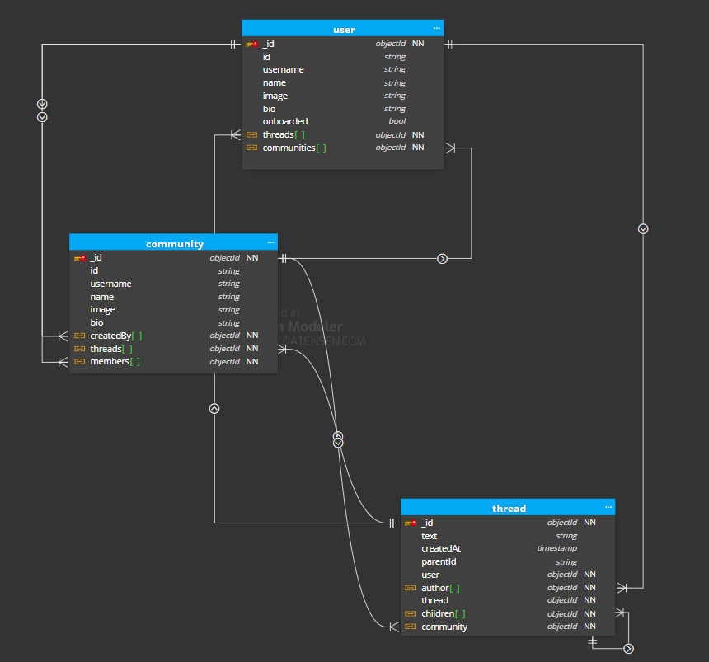

**API Details**

* **User Authentication and Authorization:**
  + /auth/sign-up : Register a new user
  + /auth/sign-in: Login a user
  + /auth/onboarding : Retrieve user profile information
* **User Profile:**
  + /root/profile/:id : Retrieve user profile information
  + /root/profile/edit : To edit user information
  + /root/profile/search : To search specific user
* **File Uploading:**
  + /root/uploadthing :To upload user files.
* **Community Handler:**
  + /root/communities/:id : To create communities.
* **Thread Creation:**
  + /root/create-thread : To create communities.
  + /root/thread/:id : To search a thread

**Features**

* **Authentication and Authorization with Clerk**: Our application utilizes Clerk for user authentication and authorization via Google, GitHub, Email& Mobile Numbers, ensuring secure access control and robust user profile management.
* **Expressing views**: Users can share opinions by creating or replying to threads on various topics along with a multilevel comment system.
* **Activity Page:**  Stay updated on recent activities with our activity page, including thread replies and likes received.
* **Complete User Profile Page:** Customize your user profile easily to reflect your preferences and identity.
* **Community Management:** Create communities effortlessly, customize descriptions, and invite others via our email templates. Community owners have authority over member roles and can manage community dynamics effectively.
* **Community-specific Threads and Search:** Facilitate focused discussions within communities and explore specific communities and user profiles easily with our search feature.

**Workflow:**

